Environmental Literacy Carbon Assessment:
--- Elementary Level, Form A ---

Science is easier to understand if you can make connections between what you know now and the new ideas that you are studying. This is a test that will help us understand what you know now. Please answer these questions as carefully and completely as you can. If you are not sure of the answer, please write about any ideas that you have. If you can help us to understand how you think about these questions, then we can do a better job of explaining science in ways that make sense to you.

Please put your initials (not your full name) in the boxes
Date ________________ | First | Middle | Last

Class ____________________________ Teacher _______________________

1. People need energy to live and grow. Which of the following is/are energy source(s) for people? Circle Yes or No for each of the following and explain your answers.

- Water YES NO
- Food YES NO
- Nutrients YES NO
- Exercise YES NO
- Sunlight YES NO
- Carbon Dioxide YES NO
- Oxygen YES NO

Please explain your answers. What is (are) the difference(s) between the things that are energy sources and the things that are not energy sources?
2. A small acorn grows into a large oak tree. Where does most of the weight of the oak tree come from? (Circle the best explanation from the list below).

a. From the natural growth of the tree.
b. From carbon dioxide in the air and water in the soil.
c. From nutrients that the tree absorbs through its roots.
d. From sunlight that the tree uses for food.

Explain why you think that the answer you chose is the best answer.

3. Which of the following is(are) energy source(s) for plants? Circle yes or no for each of the following.

a. Water YES NO
b. Light YES NO
c. Air YES NO
d. Nutrients in soil YES NO
e. Plants make their own energy. YES NO

Please explain ALL your answers, including why the things you circled “No” for are NOT sources of energy for plants.

4. A small oak tree was planted in a meadow. After 20 years, it has grown into a big tree, weighing 500 kg more than when it was planted.
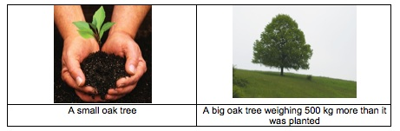

Do you think the tree will need any of the following things to grow and gain weight? Please circle Yes or No and explain your choice.

Things | Does the tree need it to grow bigger? | If you circled yes, explain how the tree uses it. What happens to it inside the tree?
Sunlight | Yes No
Soil | Yes No
Water | Yes No
Air | Yes No

5. The 4 pictures below show 4 events happening. Do you think air is needed for each of the events? Please circle Yes or No and explain your choice.

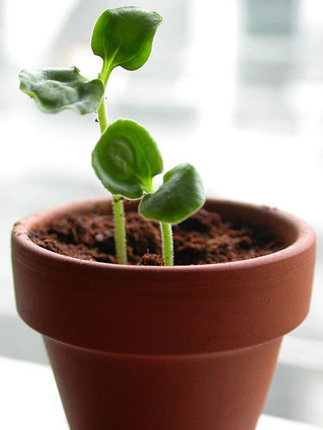 |  | 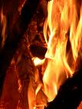 | 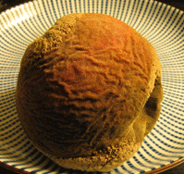

A. Plant growth B. Girl running C. Burning wood D. Food decay

Events | Does the event need air?  (Circle) | If you circled yes, explain how is air used in the event?
A. Plant growth | Yes No
B. Girl running | Yes No
C. Burning wood | Yes No
D. Food decay | Yes No

Do the events that you circled “Yes” use air in similar ways or in different ways? Please explain your answer.
6. When an apple is left outside for a long time, it rots.

a. What causes the apple to rot?

b. The weight of the apple decreases as it rots. What do you think happens to the matter or stuff that was once in the apple?

c. Is there energy involved when the apple rots?

Circle one: Yes / No

Please explain your answer.

7. A tree falls in the forest. After many years, the tree will appear as a long, soft lump on the forest floor.

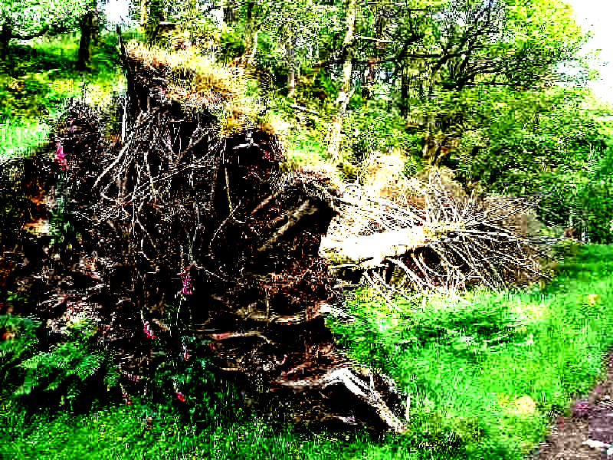

a. The lump on the forest floor weighs less than the original tree. What happened to it? Where would you find the matter that used to be in the tree?

b. What caused the weight became less? Explain as much as you can how these changes happened.

c. Is energy involved when the tree decays?

Circle one: Yes / No

If your answer is yes, please explain how energy is involved.

8. Explain how the following living things are connected with one another:

- Grass
- Cows
- Human beings
- Decomposing bacteria

